786
Name: Muhammad Sherjeel Akhtar
Roll No: 20p-0101
Subject: Database System Lab
Lab Task: 05
Submitted To Respect Sir: Muhammad Usman
Section: 5A

Question: 01

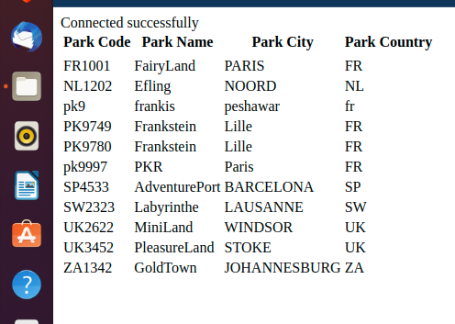
.
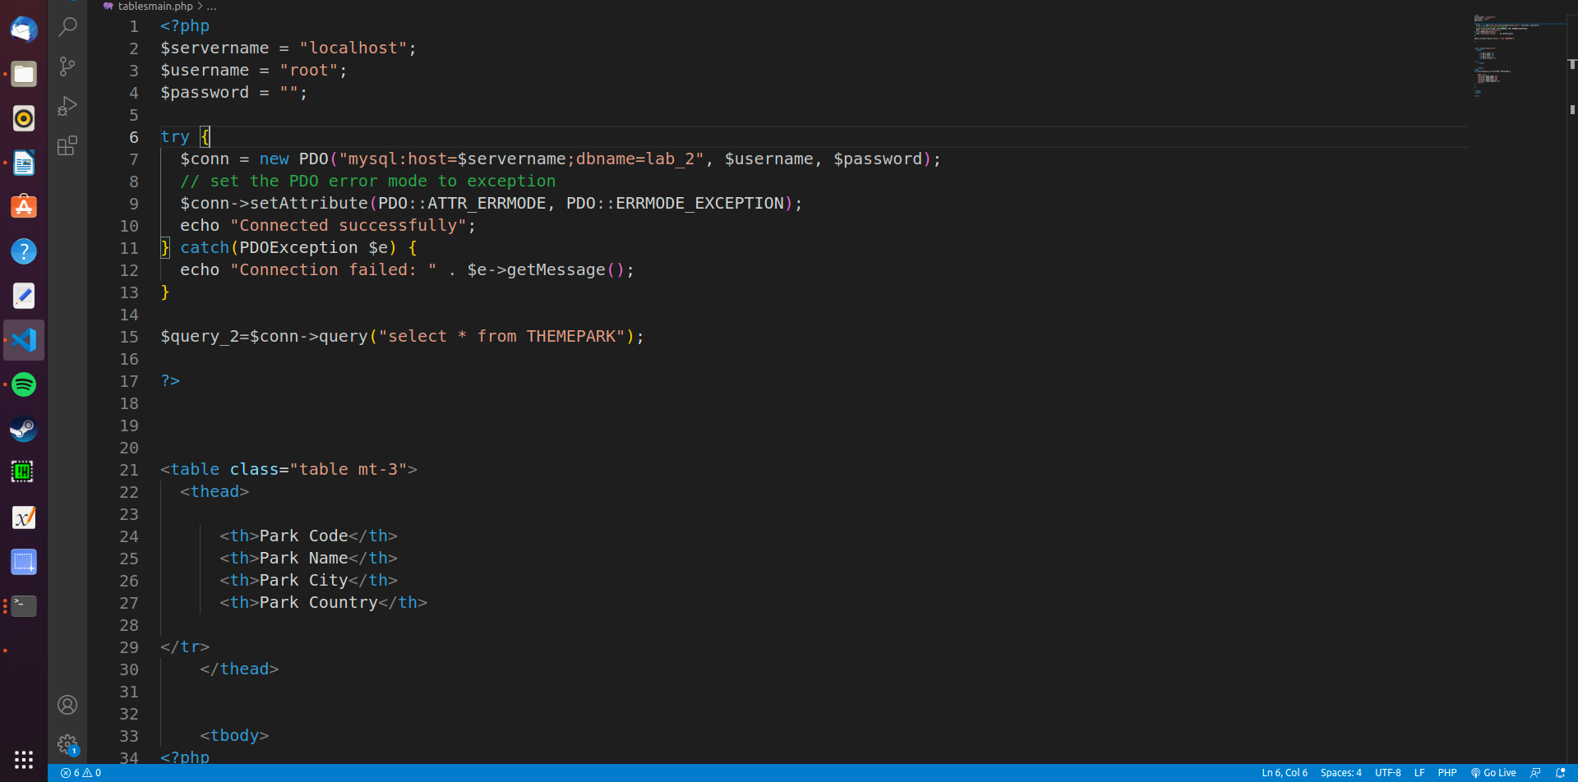
.
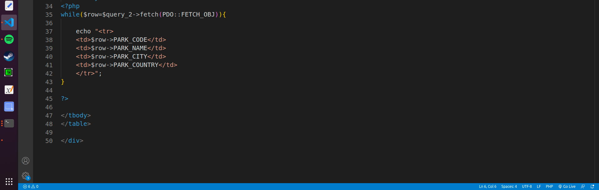

Question: 02
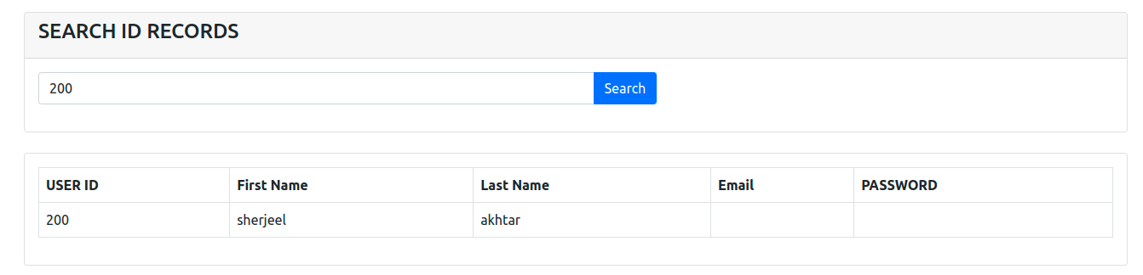
.
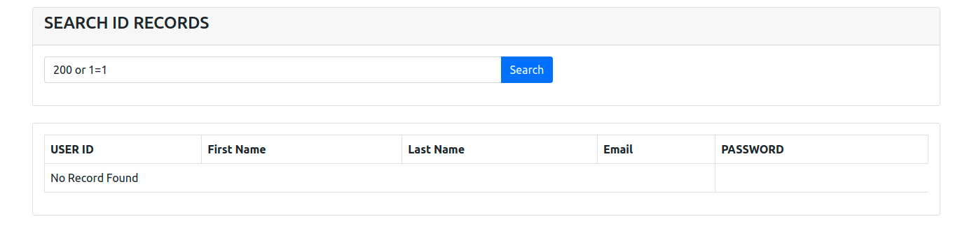
.
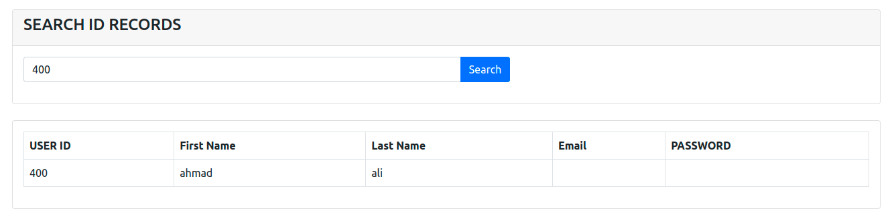
.
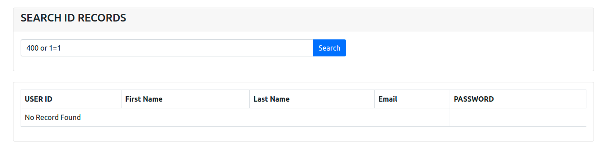
.

Source Code:
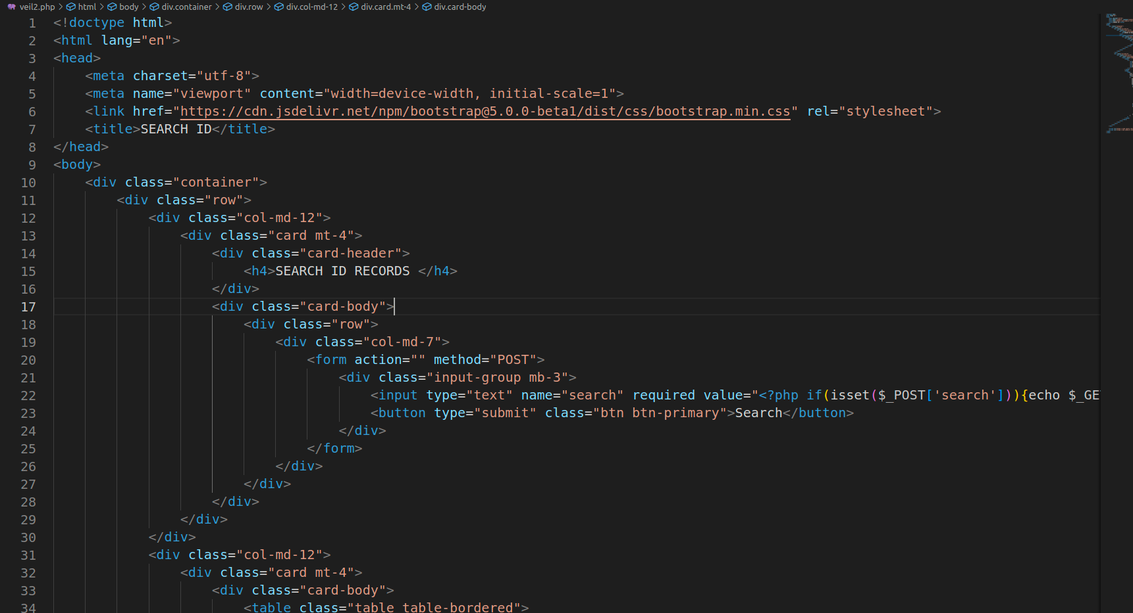
.
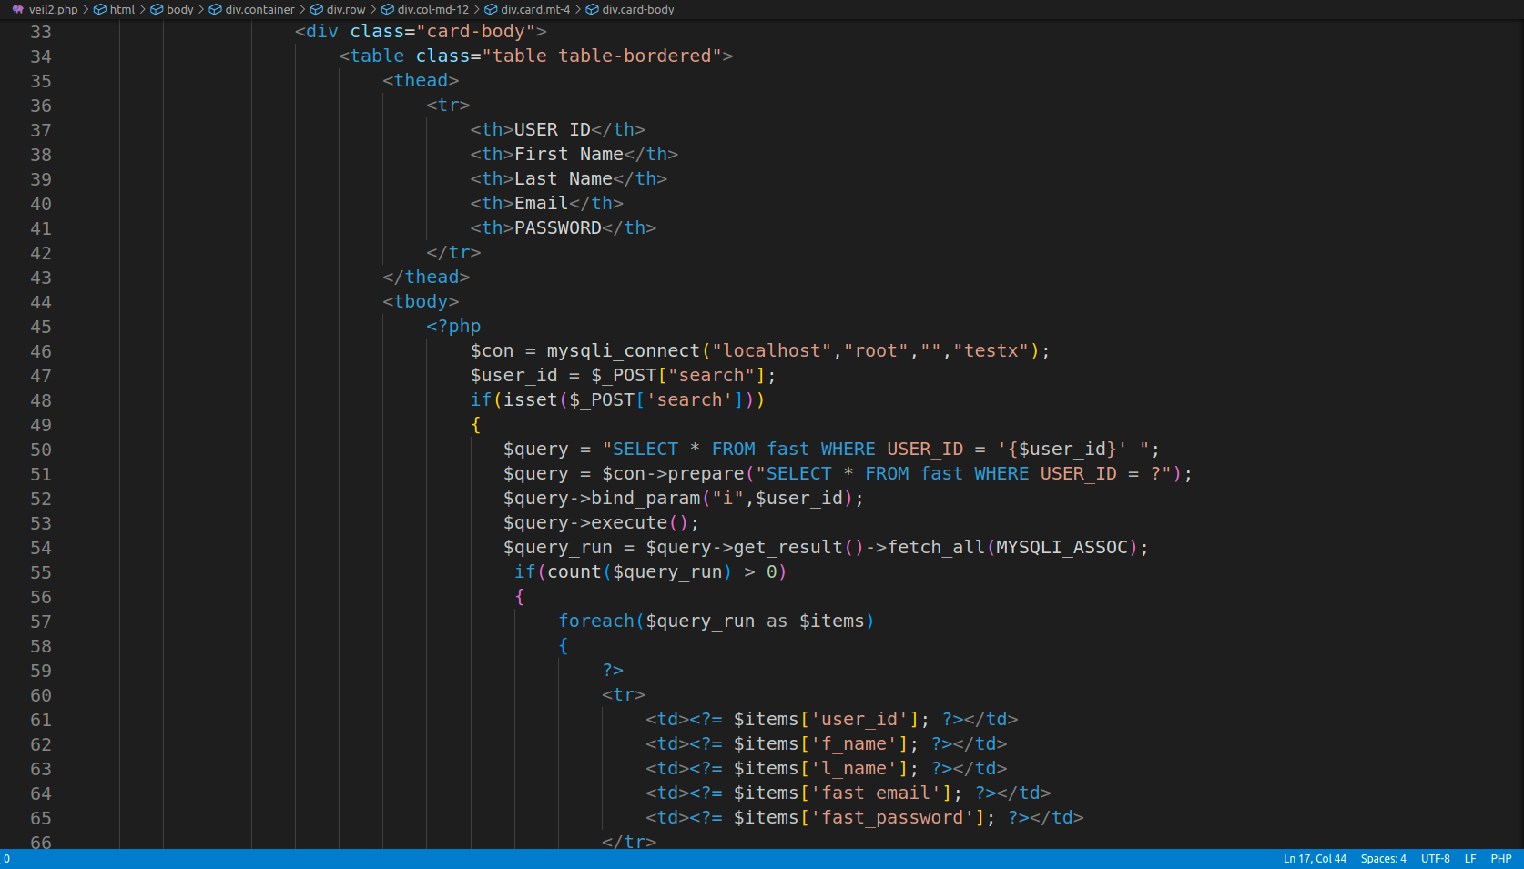
.
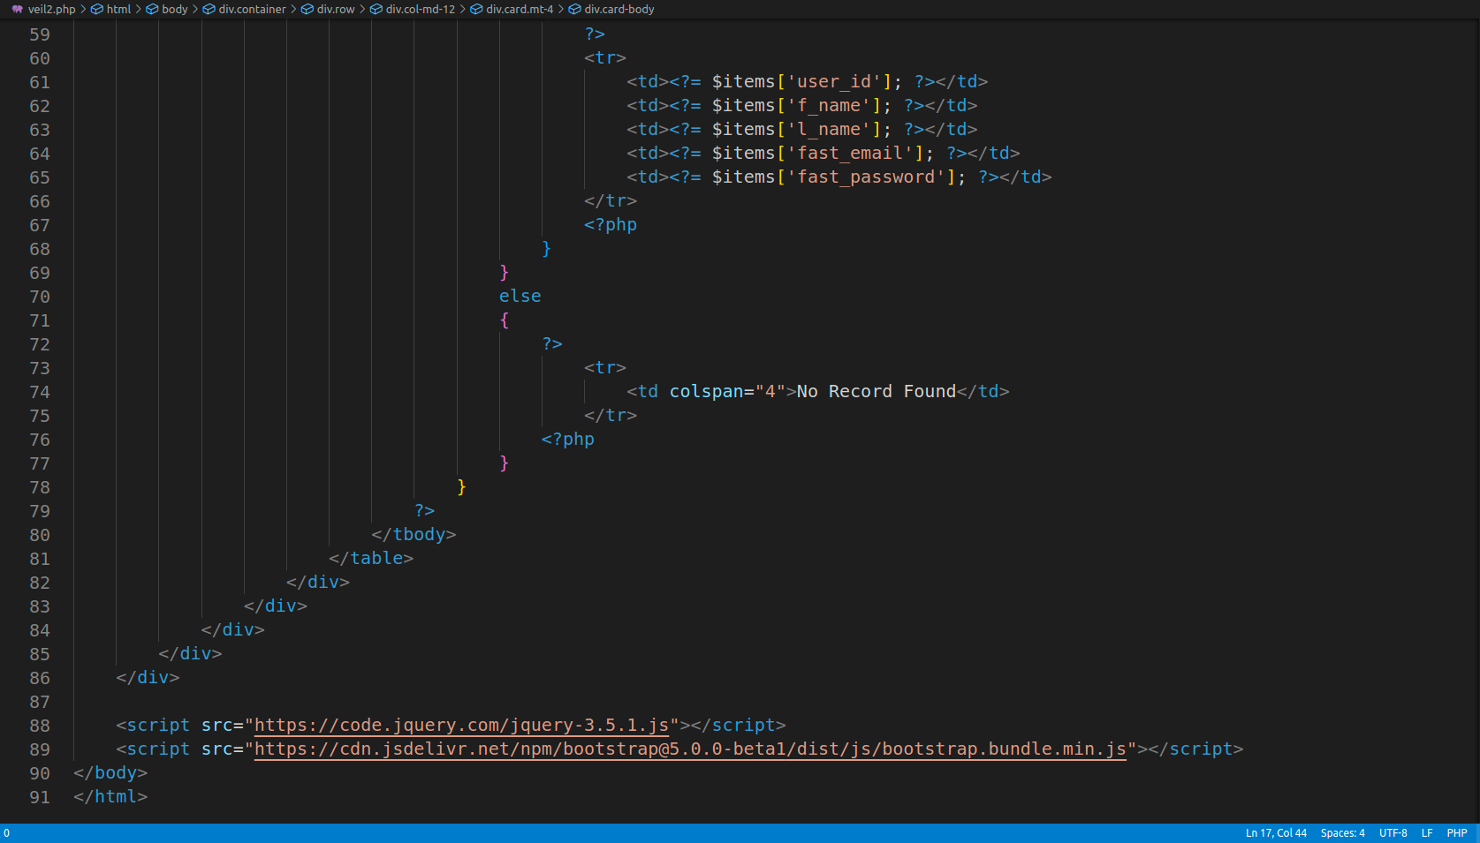

END.

